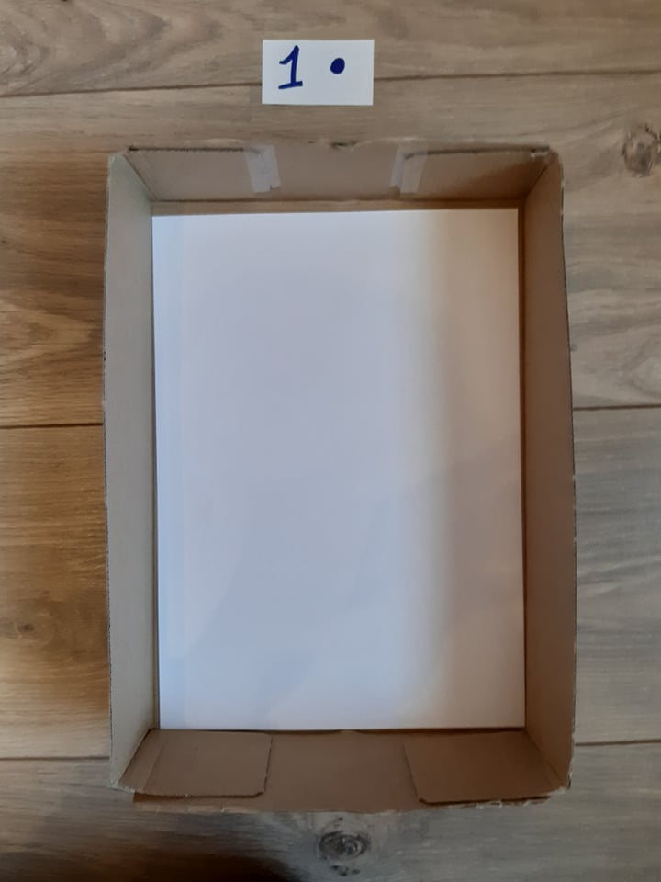

KERSTSTER MET STRIJKPARELS

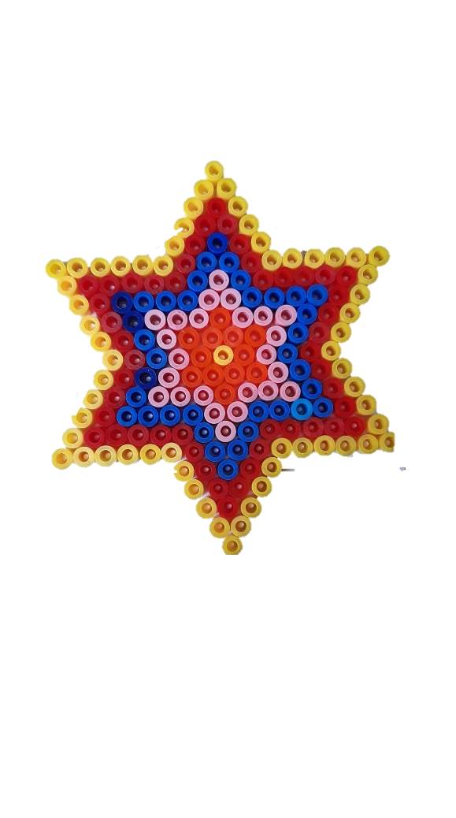[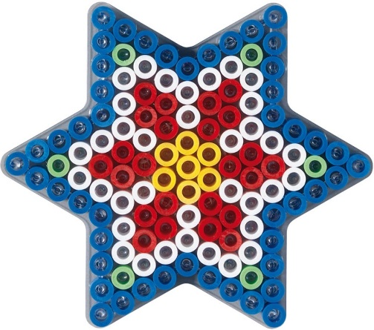](https://www.google.be/url?sa=i&url=https%3A%2F%2Fwww.bol.com%2Fnl%2Fp%2Fhama-strijkkralenbordje-maxi-ster%2F9200000058039650%2F&psig=AOvVaw3IfL-3WNPC7hE5HDPYHYIr&ust=1586273787843000&source=images&cd=vfe&ved=0CAIQjRxqFwoTCPjey8uQ1OgCFQAAAAAdAAAAABAJ)[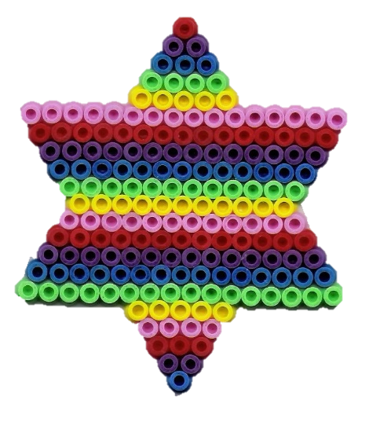](https://www.google.be/url?sa=i&url=https%3A%2F%2Fwww.pinterest.ie%2Fpin%2F351140102176288961%2F&psig=AOvVaw3IfL-3WNPC7hE5HDPYHYIr&ust=1586273787843000&source=images&cd=vfe&ved=0CAIQjRxqFwoTCPjey8uQ1OgCFQAAAAAdAAAAABAU)[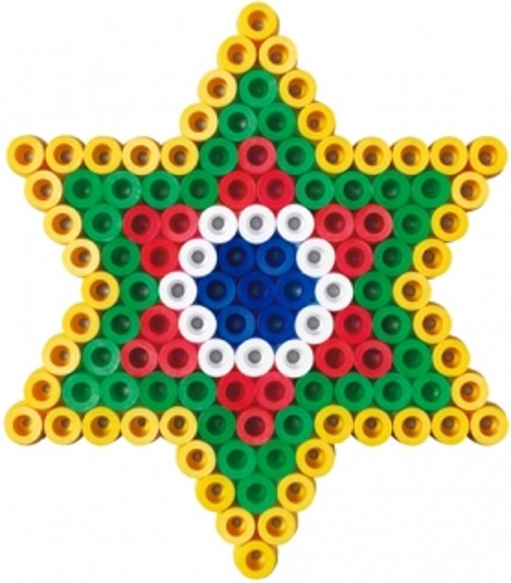](https://www.google.be/url?sa=i&url=https%3A%2F%2Fwww.bol.com%2Fnl%2Fp%2Fhama-maxi-strijkkralenset-ster-250-stuks%2F9200000058039648%2F&psig=AOvVaw3IfL-3WNPC7hE5HDPYHYIr&ust=1586273787843000&source=images&cd=vfe&ved=0CAIQjRxqFwoTCPjey8uQ1OgCFQAAAAAdAAAAABAP)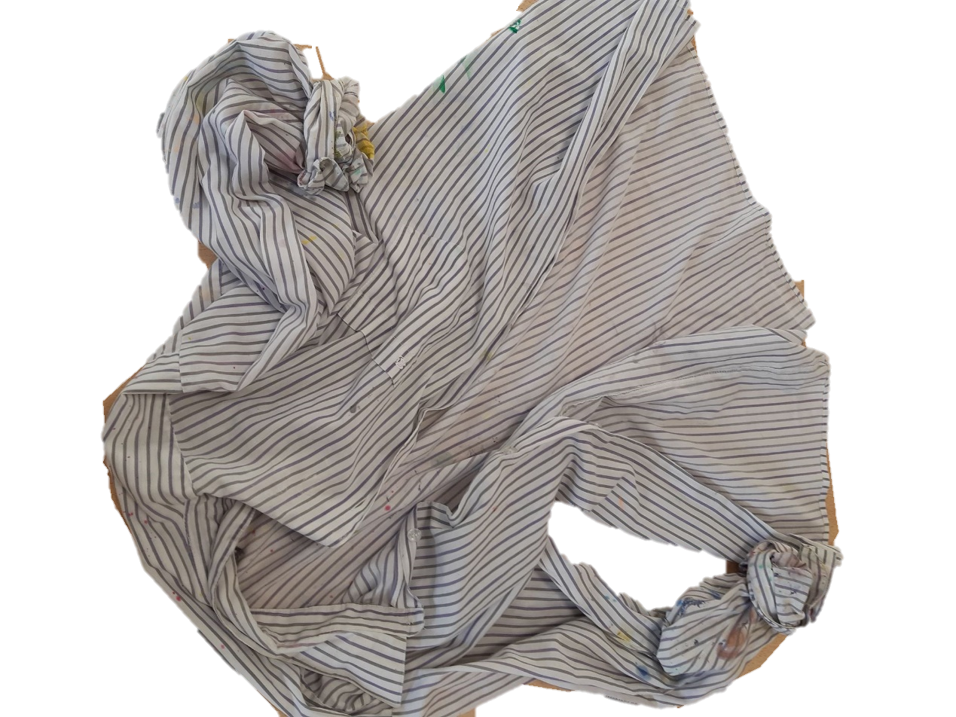

SCHORT AANDOEN

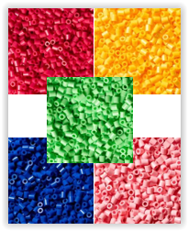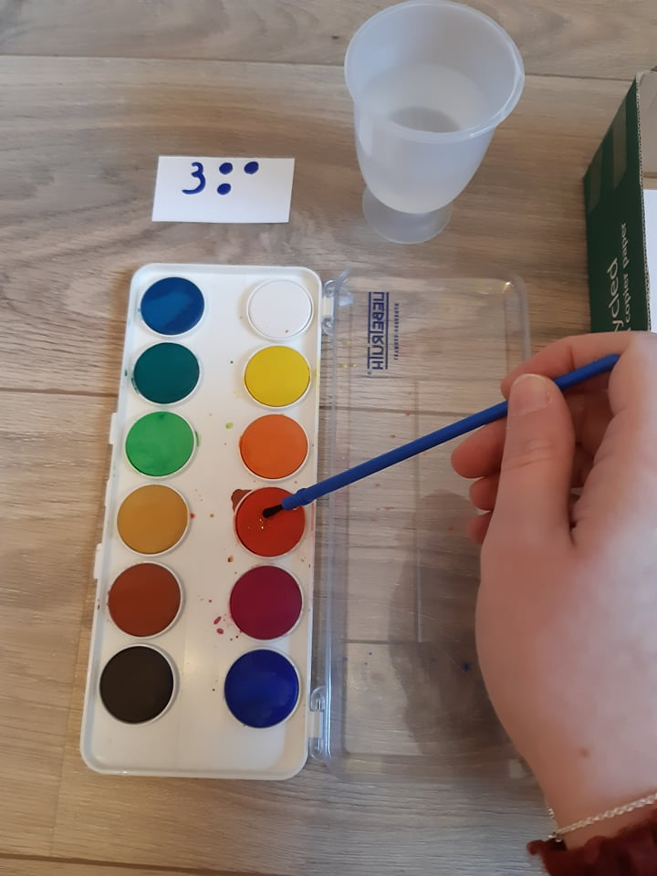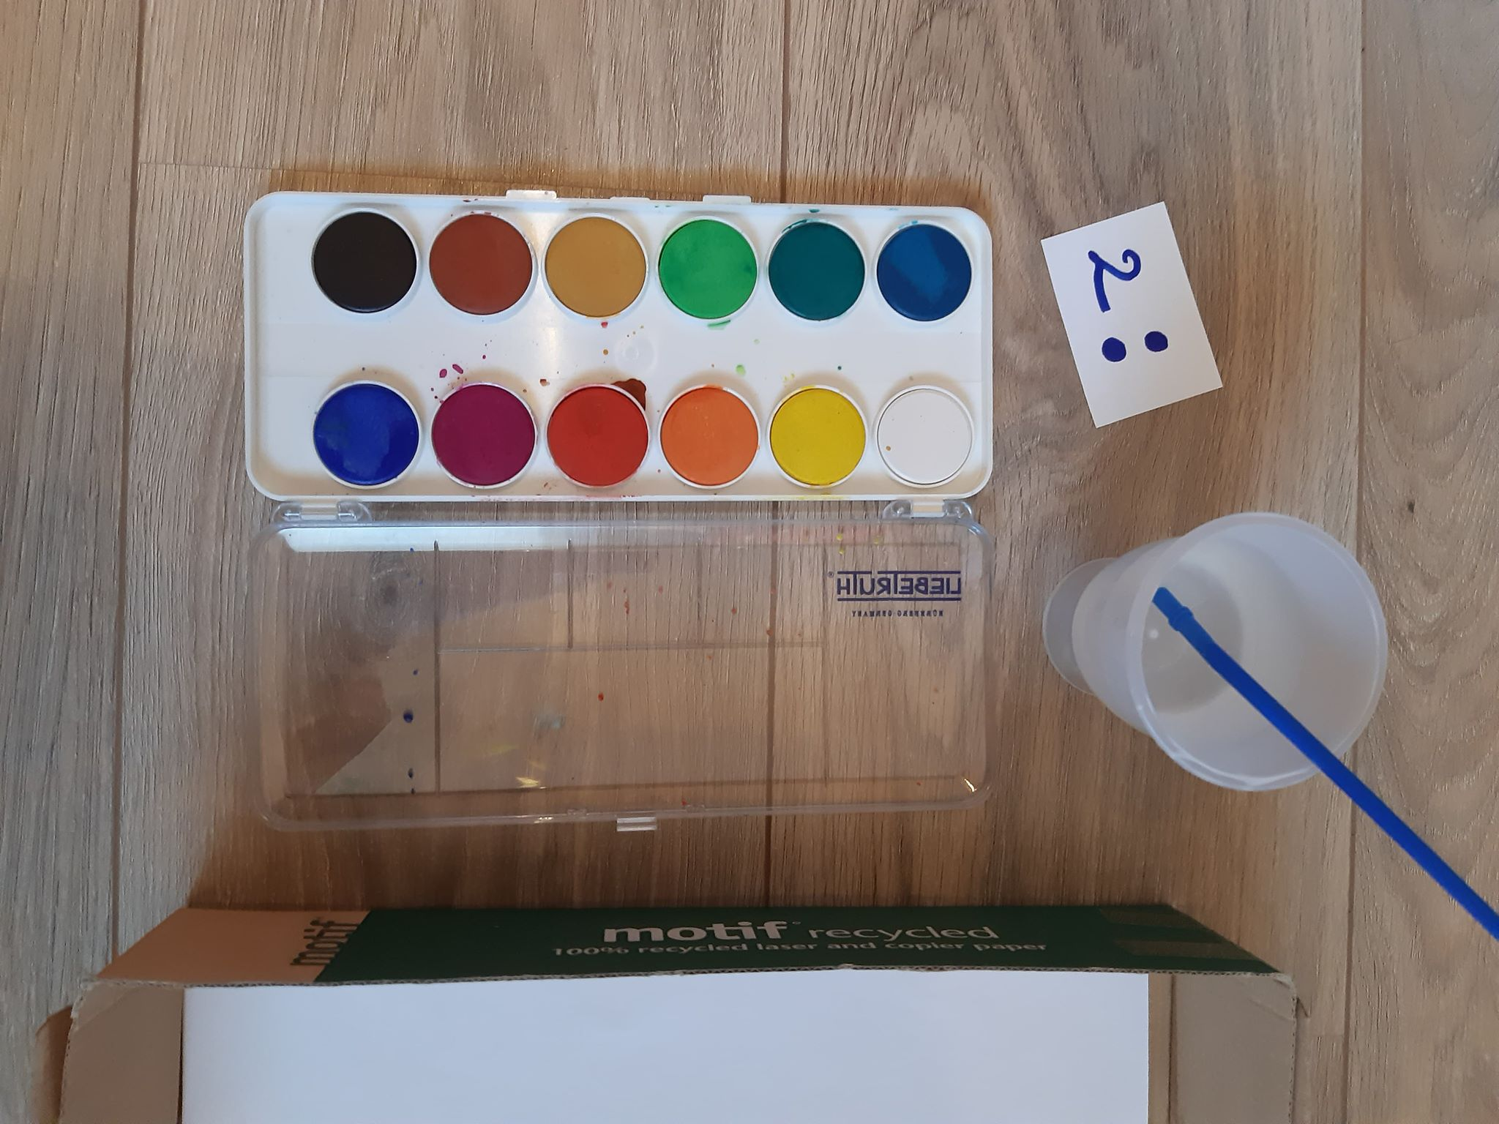

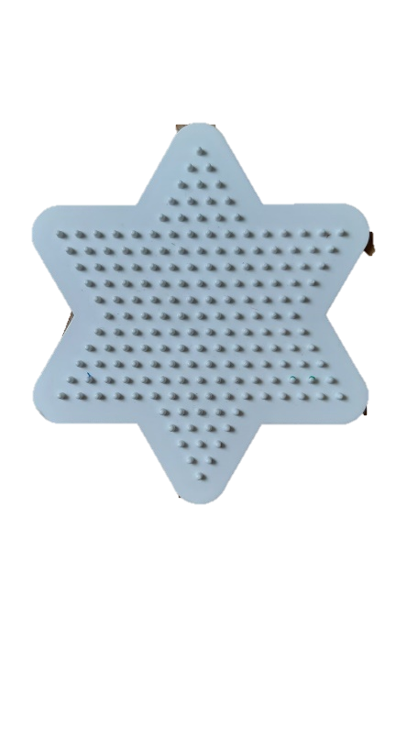

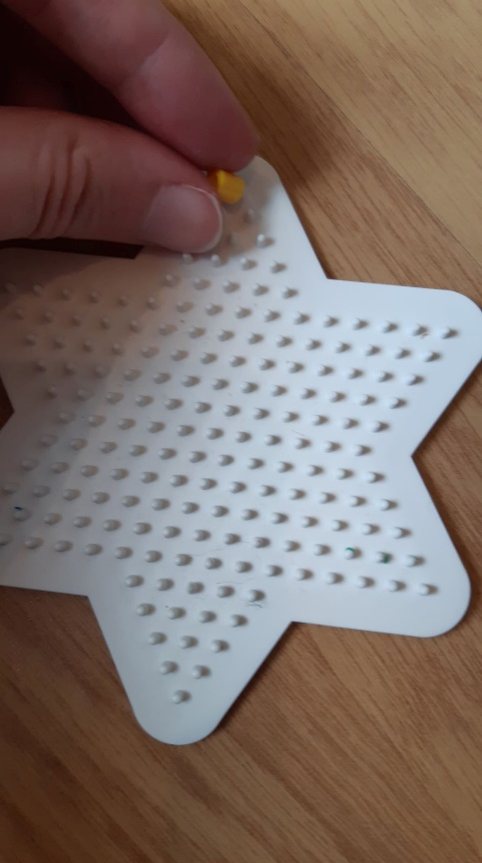

STRIJKPARELS OP DE STER DOEN

AL HET MATERIAAL UITHALEN

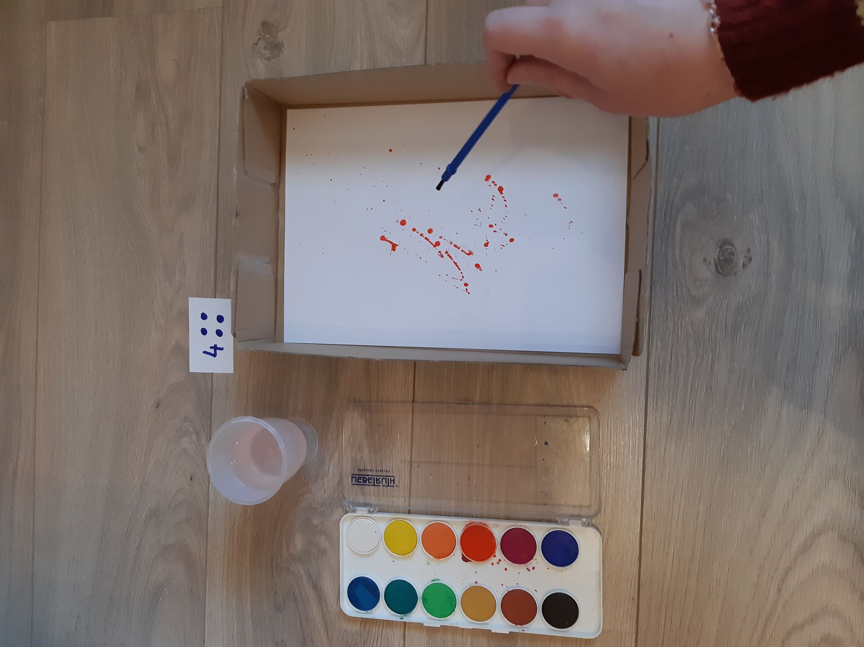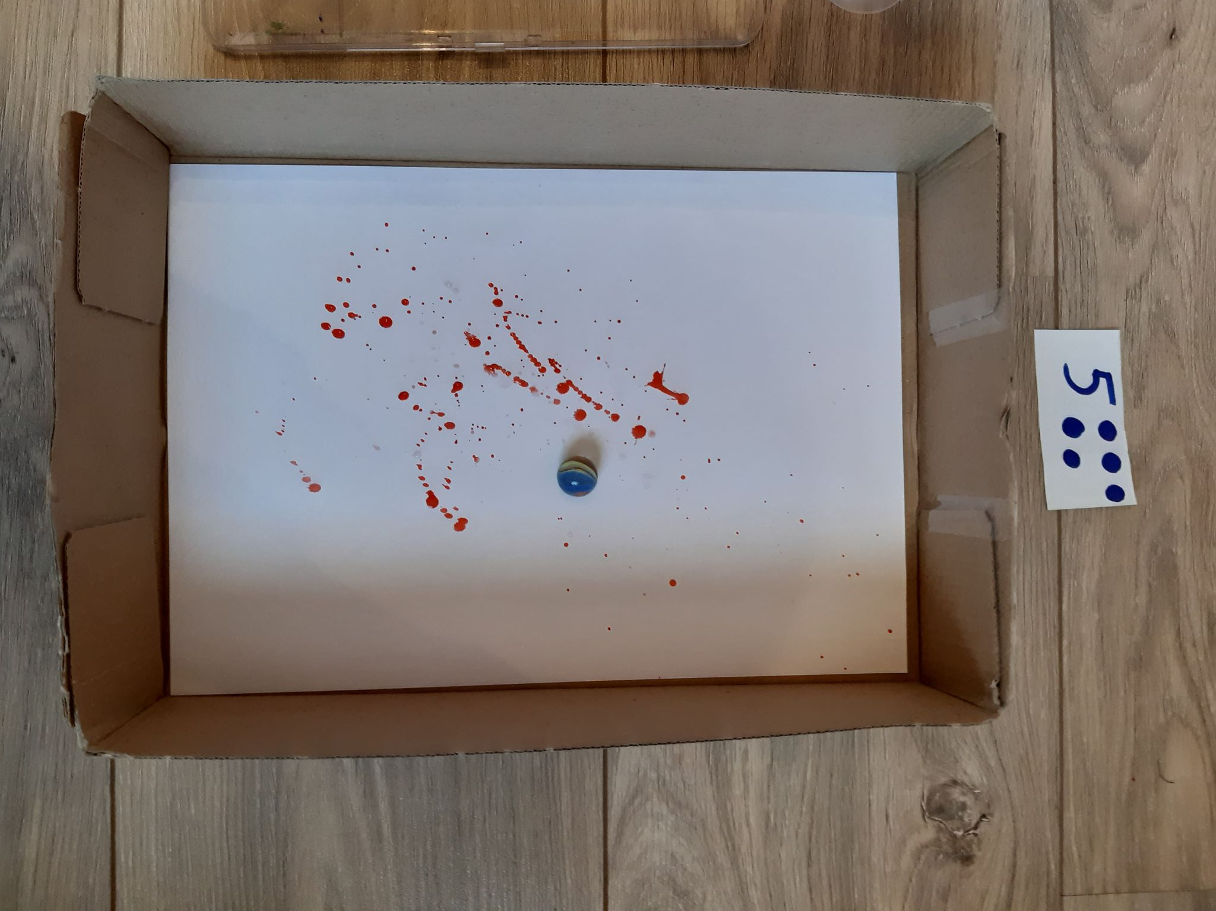

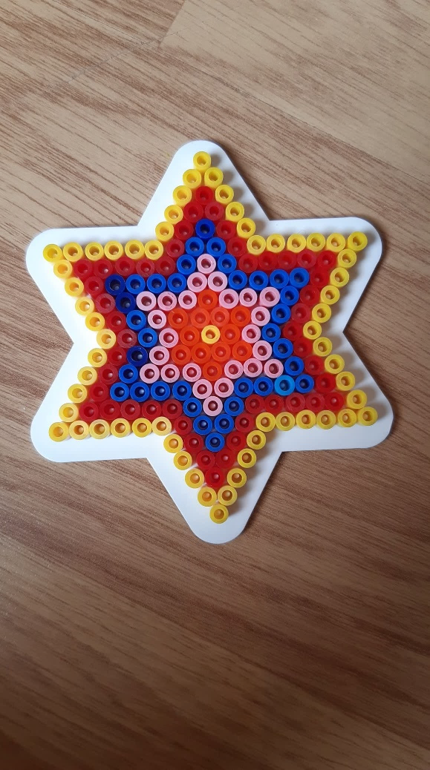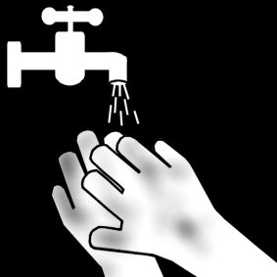



EINDE

HANDEN WASSEN

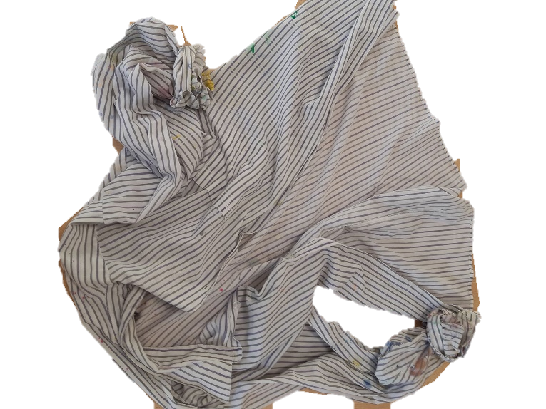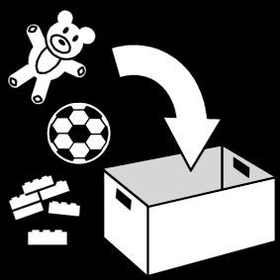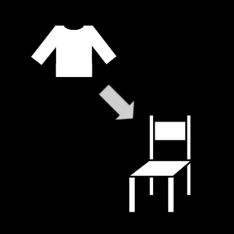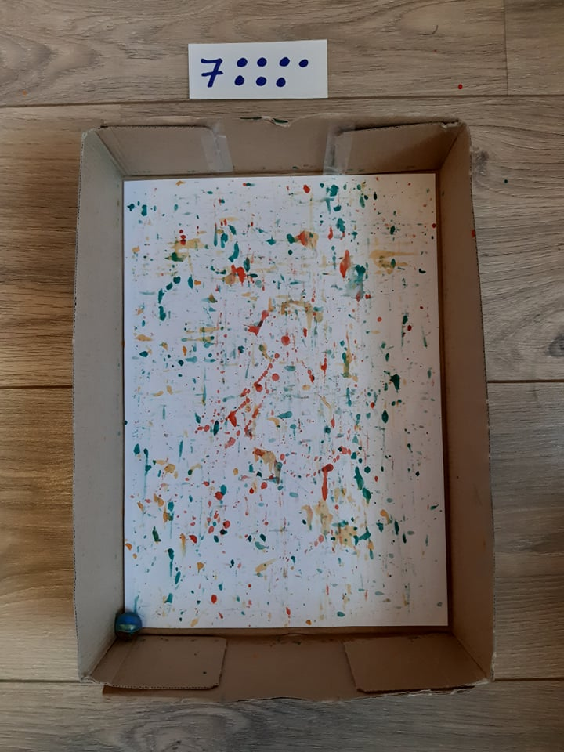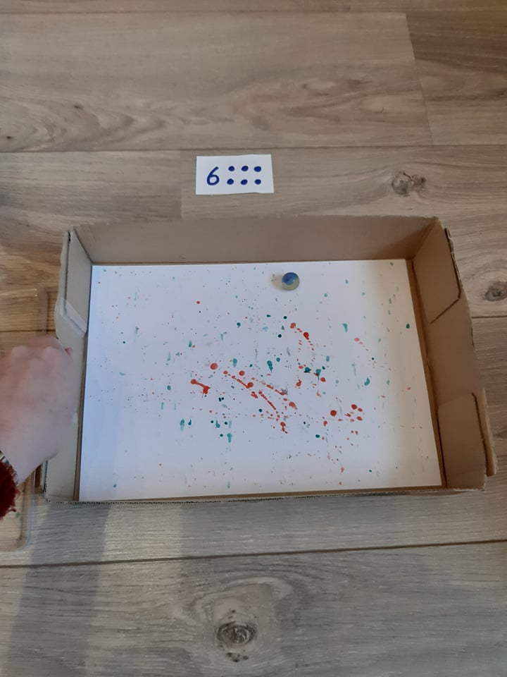

ALLES OPRUIMEN

SCHORT AAN DE STOEL